ECE – 390

INVERTER

**S-EDIT**

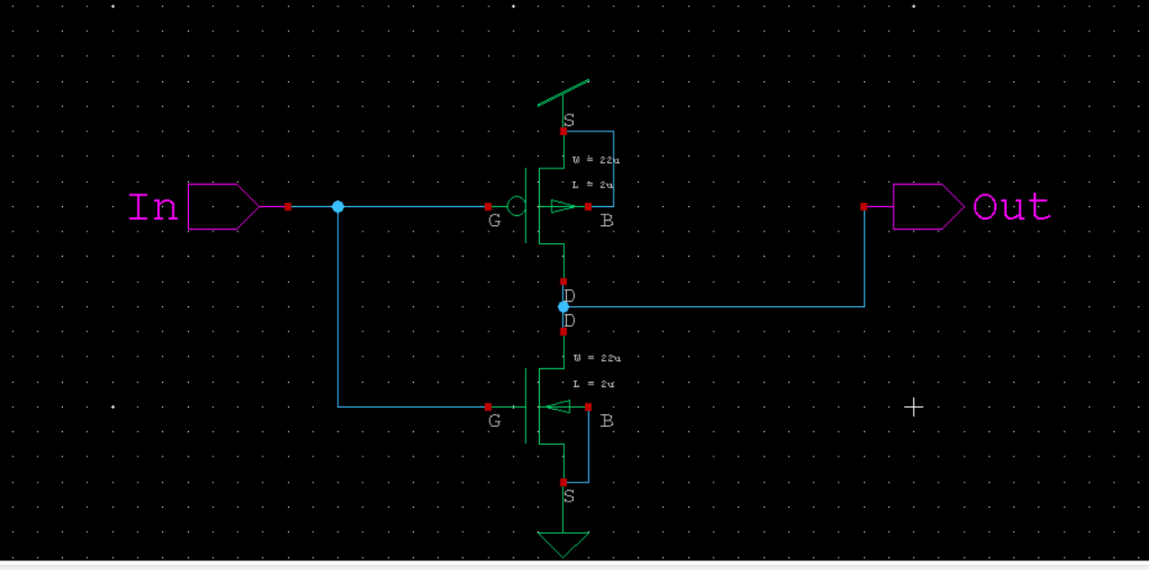

**T – SPICE**

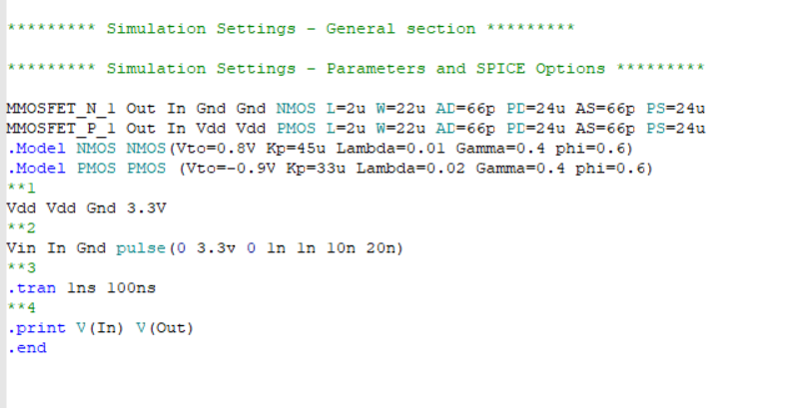

**W-EDIT WAVEFORM**

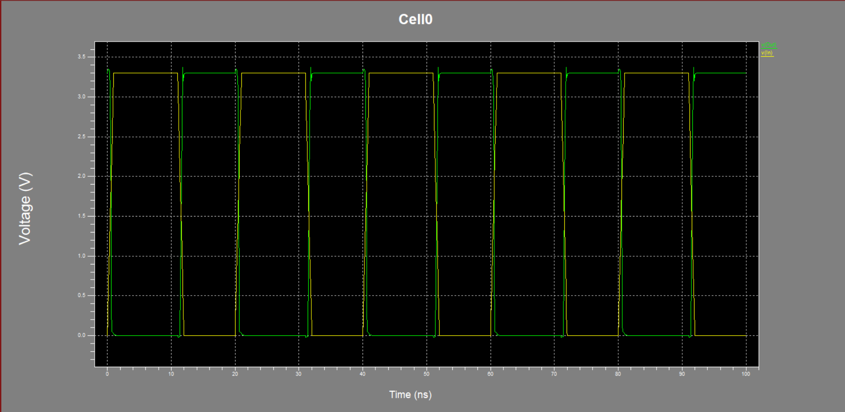

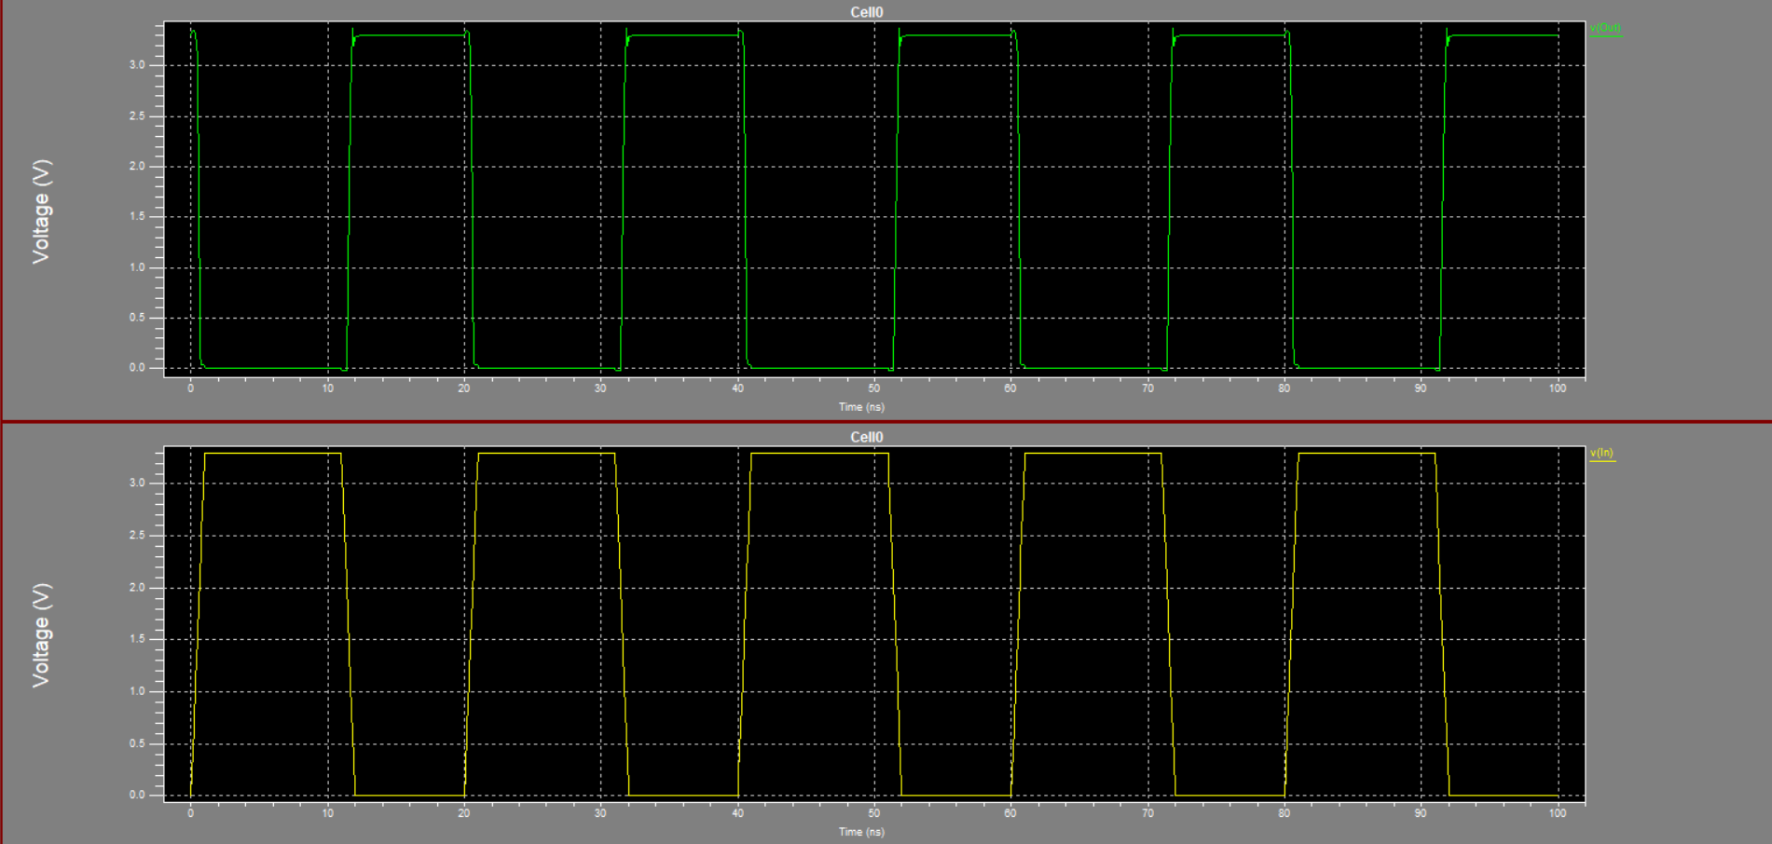

NAND GATE

**S-EDIT**

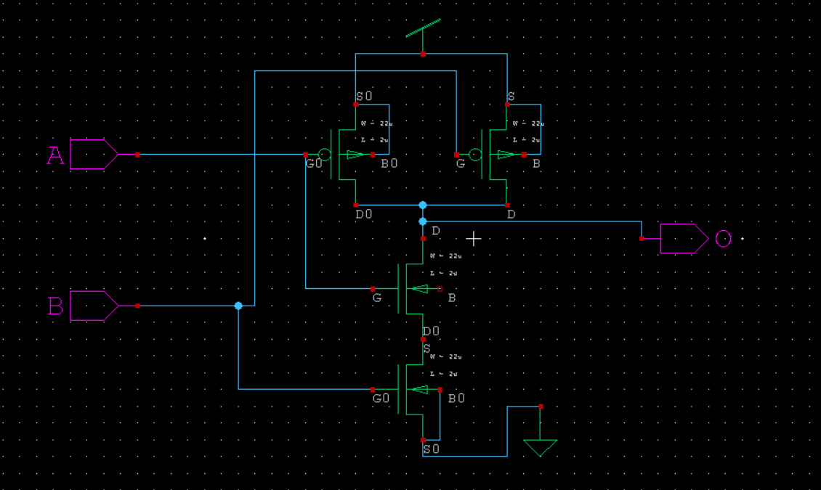

**T-SPICE**

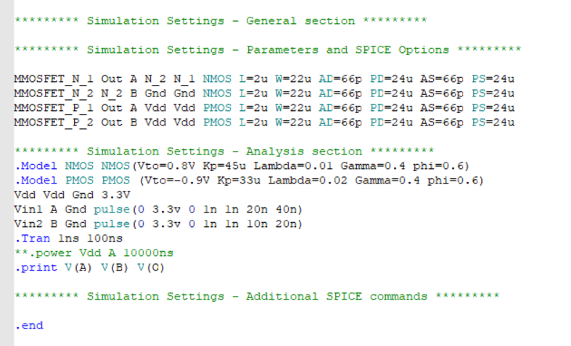

**W-EDIT WAVEFORM**

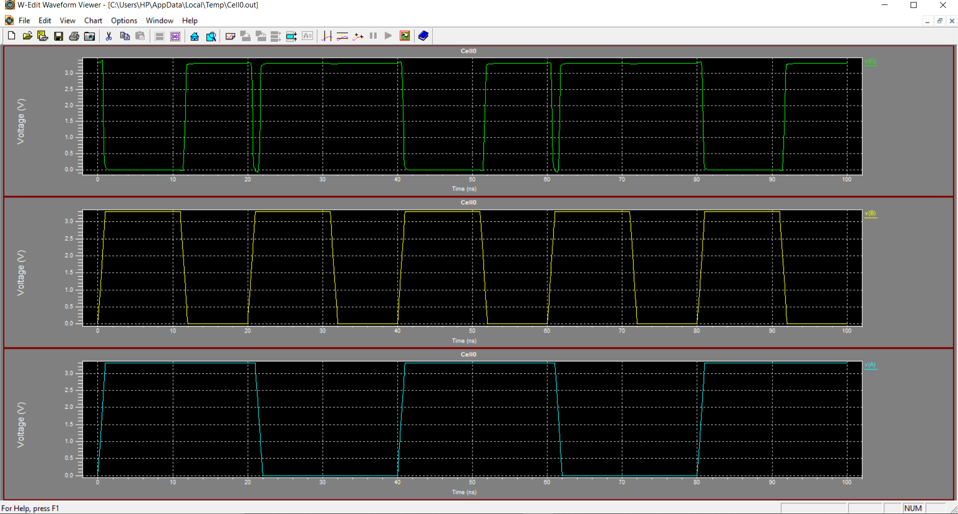

NOR GATE

**S-EDIT**

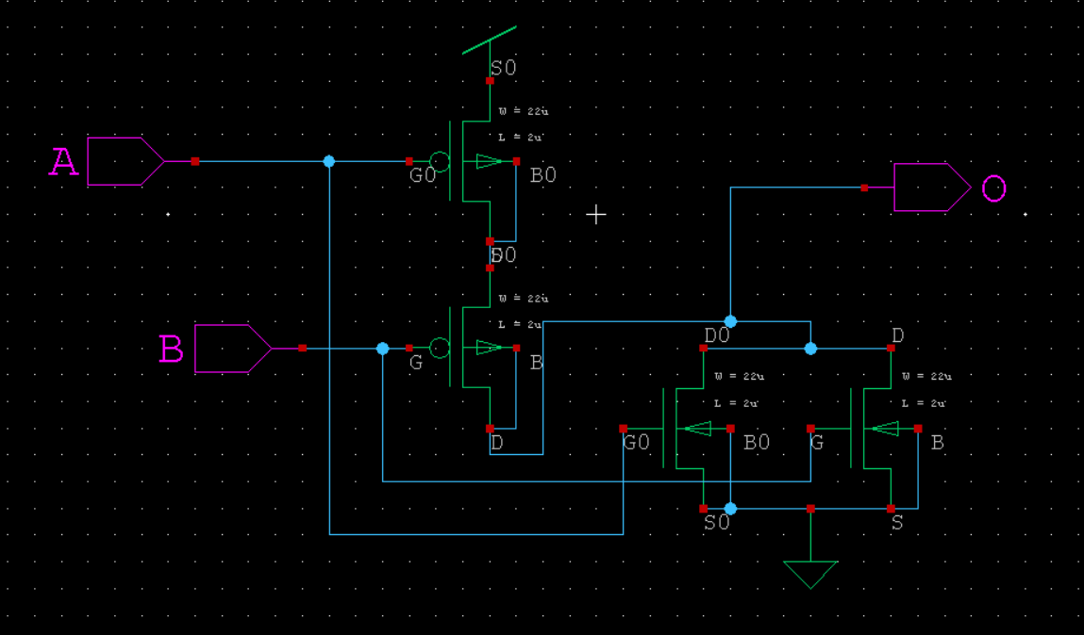

**T-SPICE**

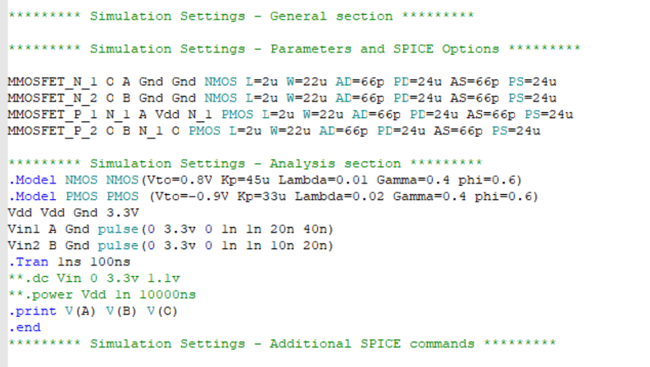

**W-EDIT WAVEFORM**

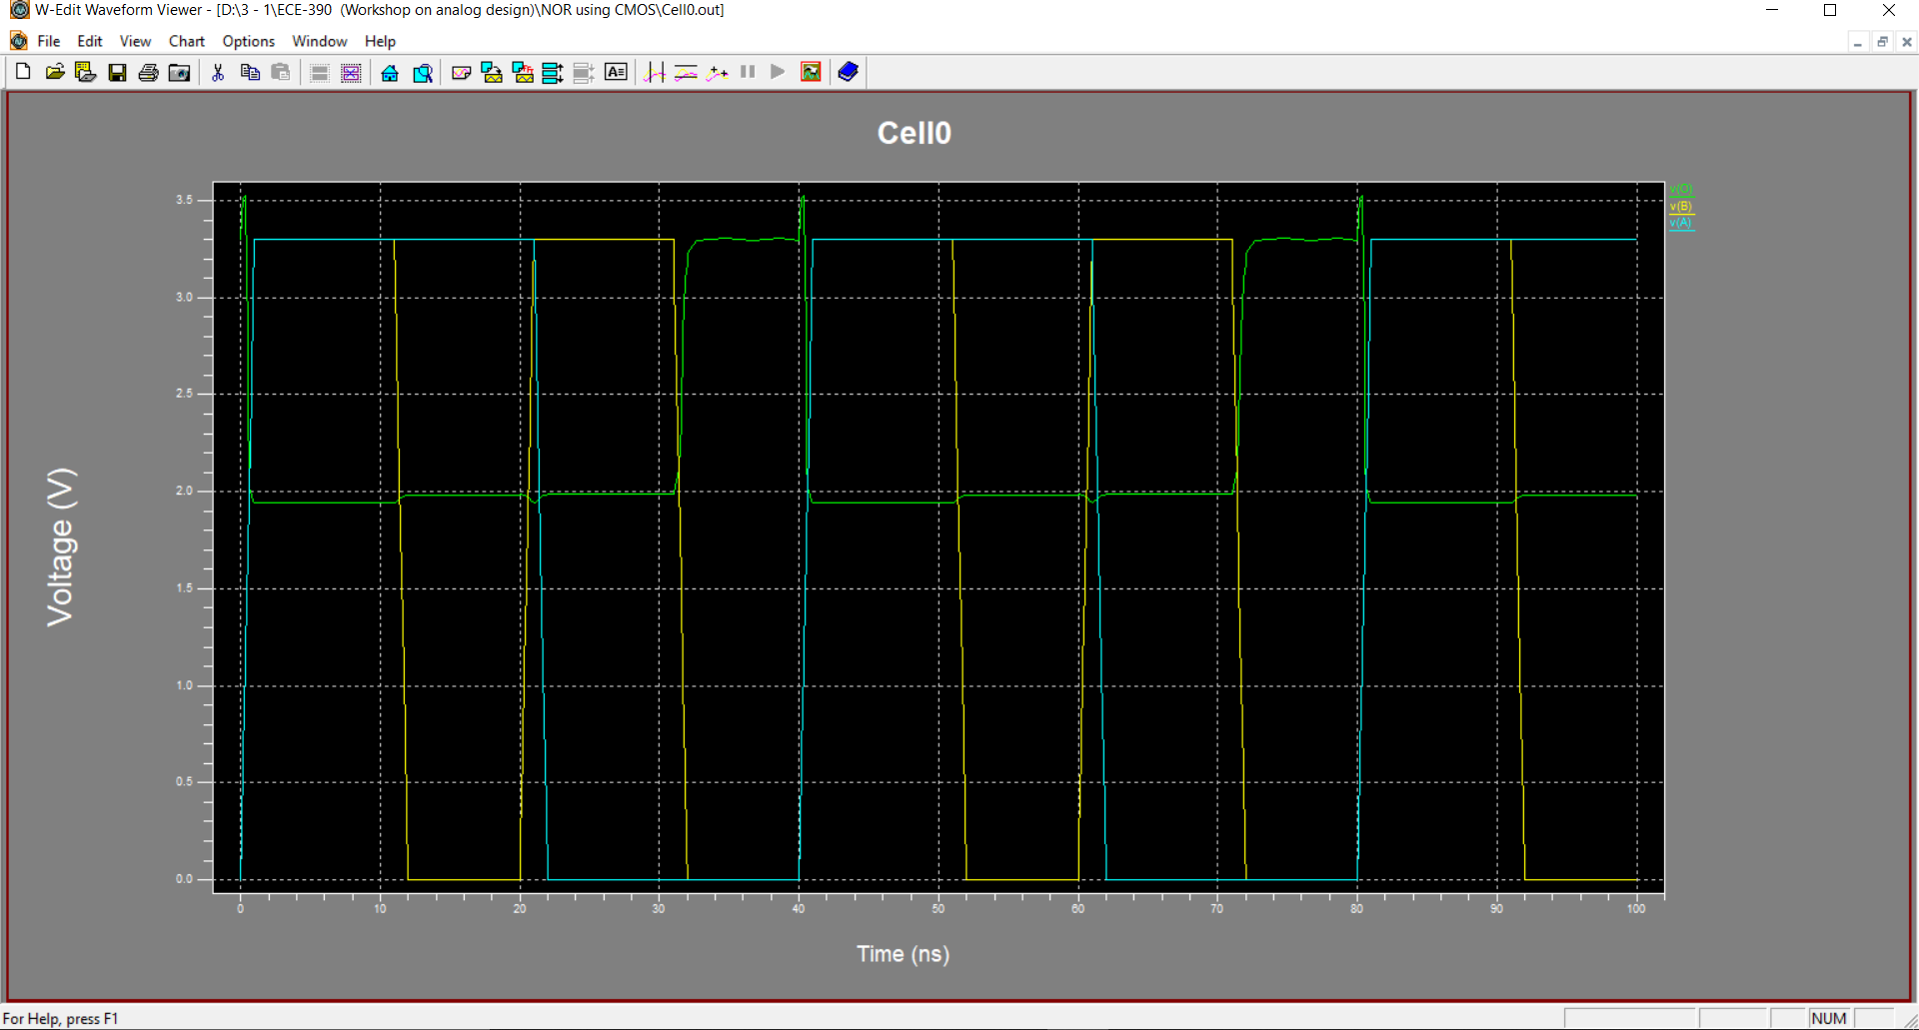

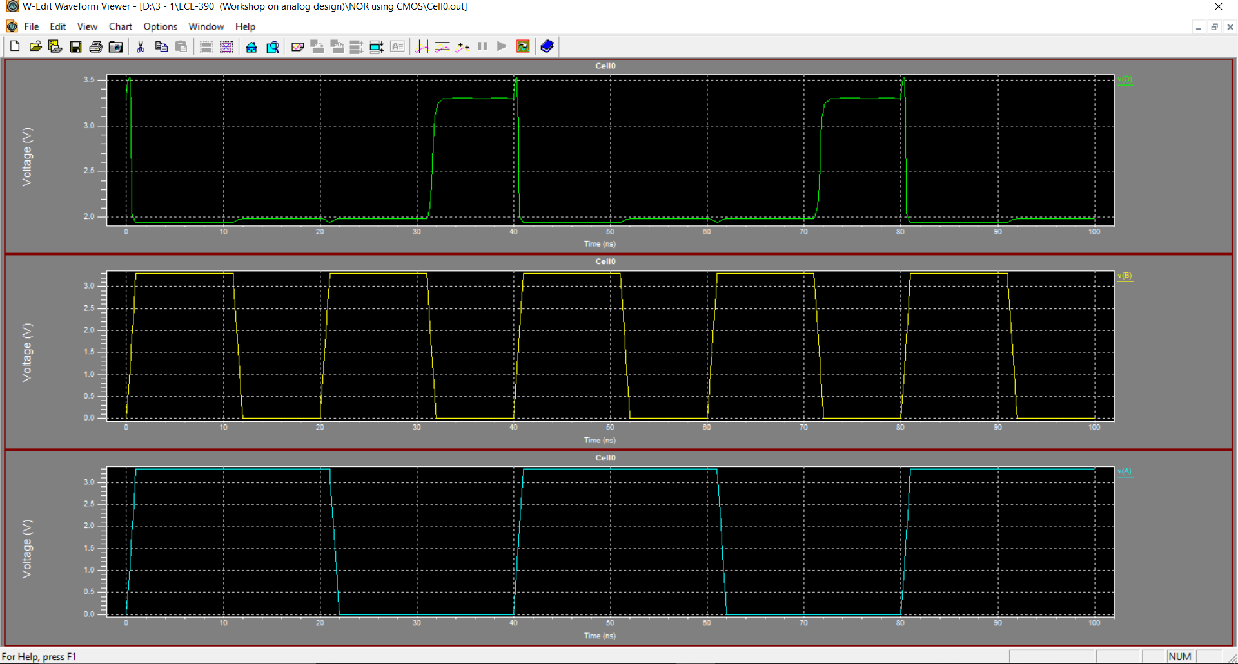

HALF ADDER

**S-EDIT**

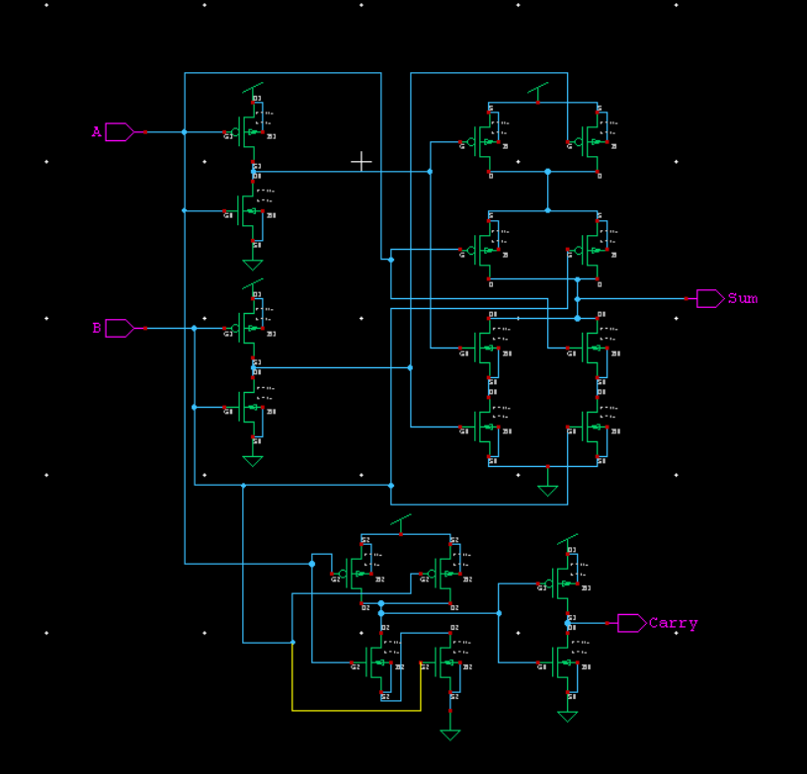

**T-SPICE**

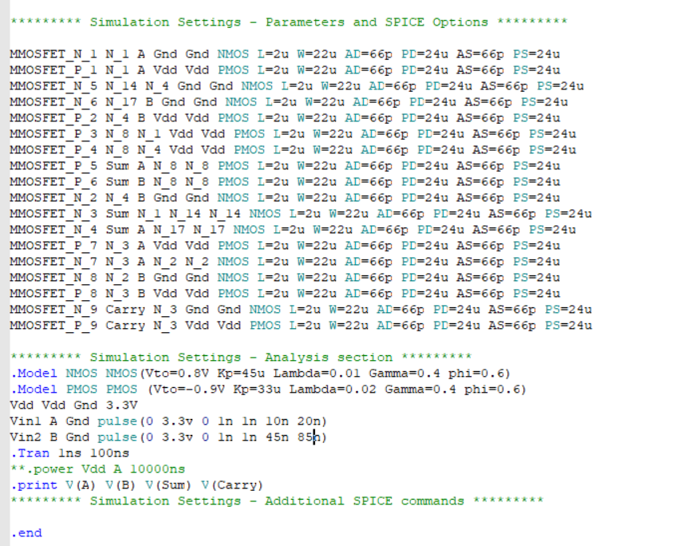

**W-EDIT WAVEFORM**

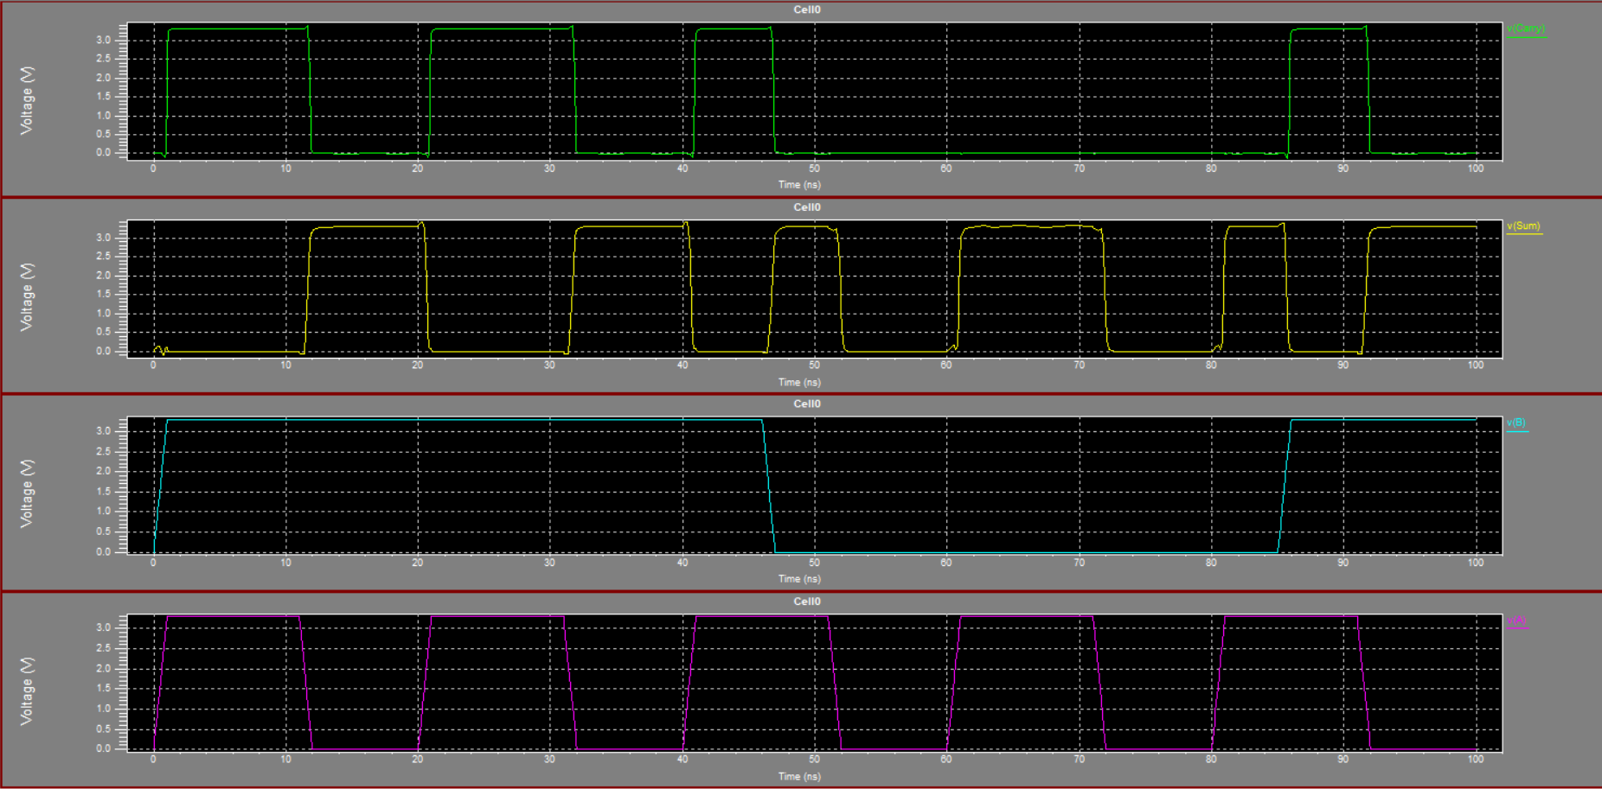

FULL ADDER

**S-EDIT**

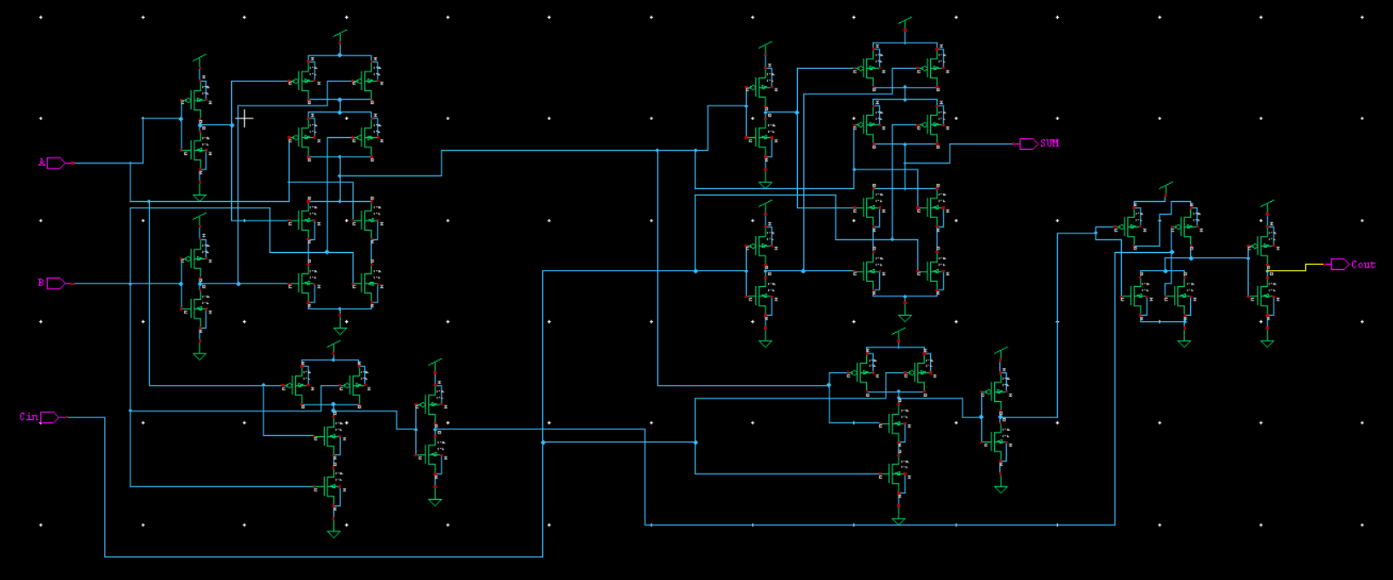

**T-SPICE**

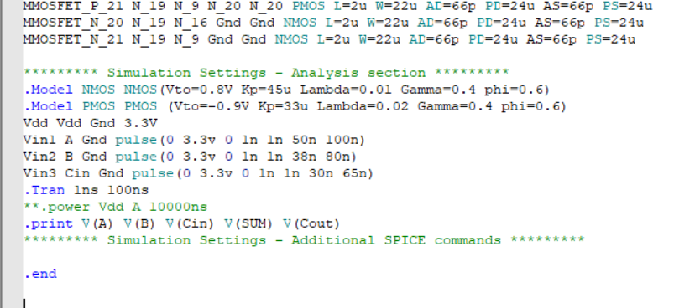

**W-EDIT WAVEFORM**

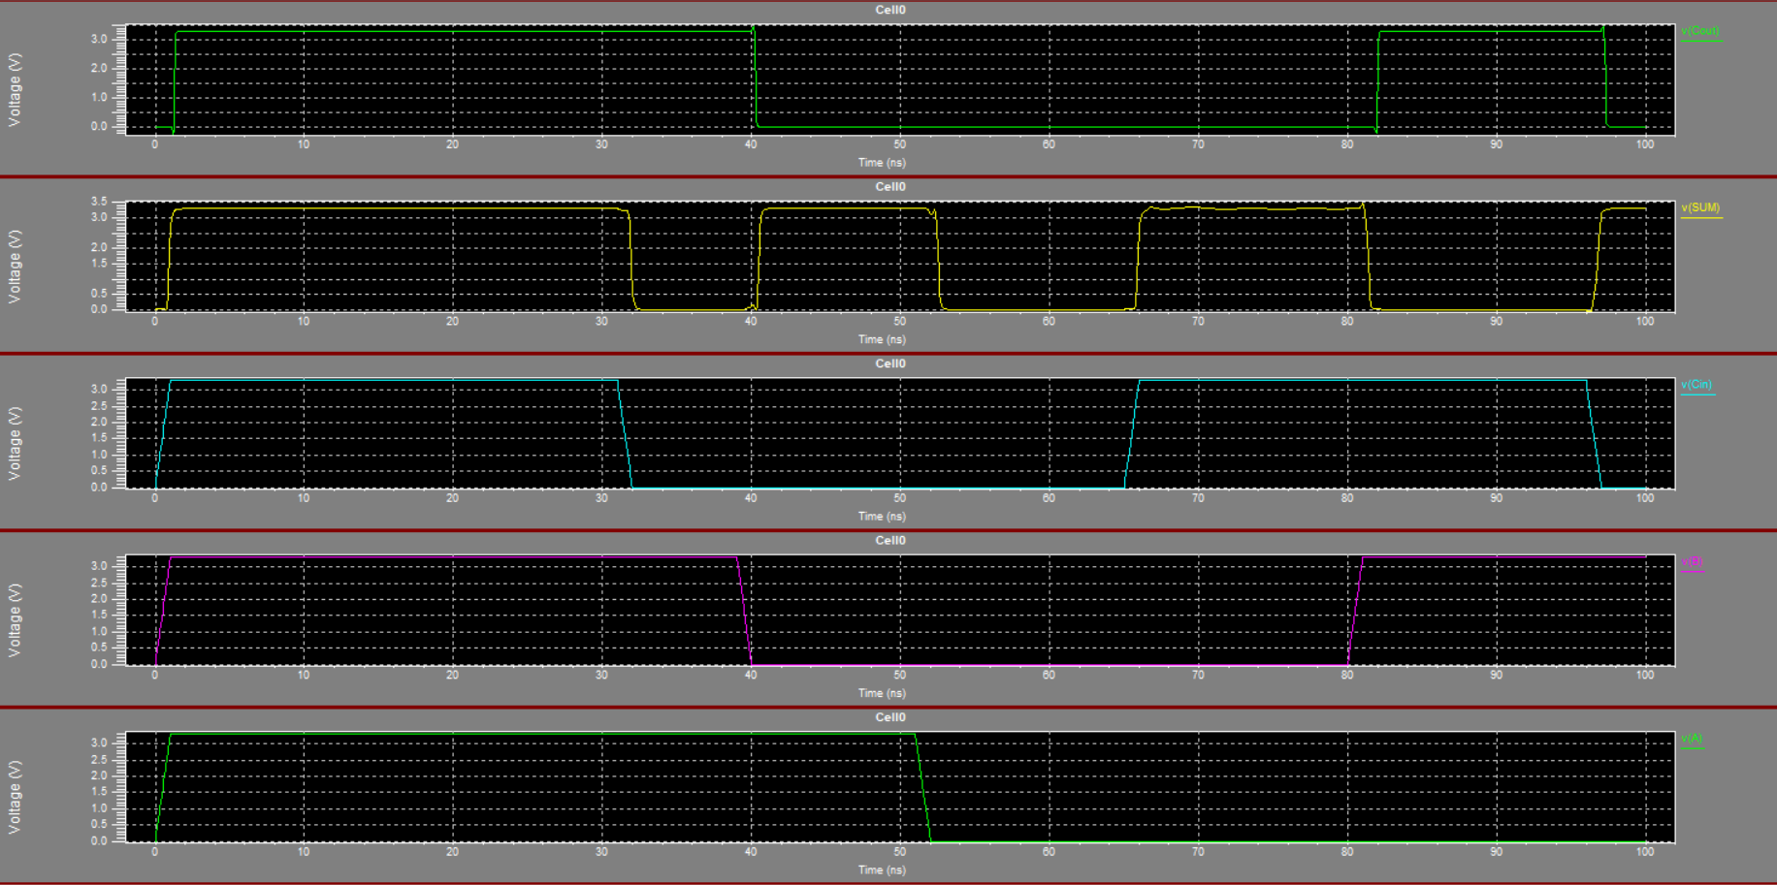

**INPUT WAVEFORM**

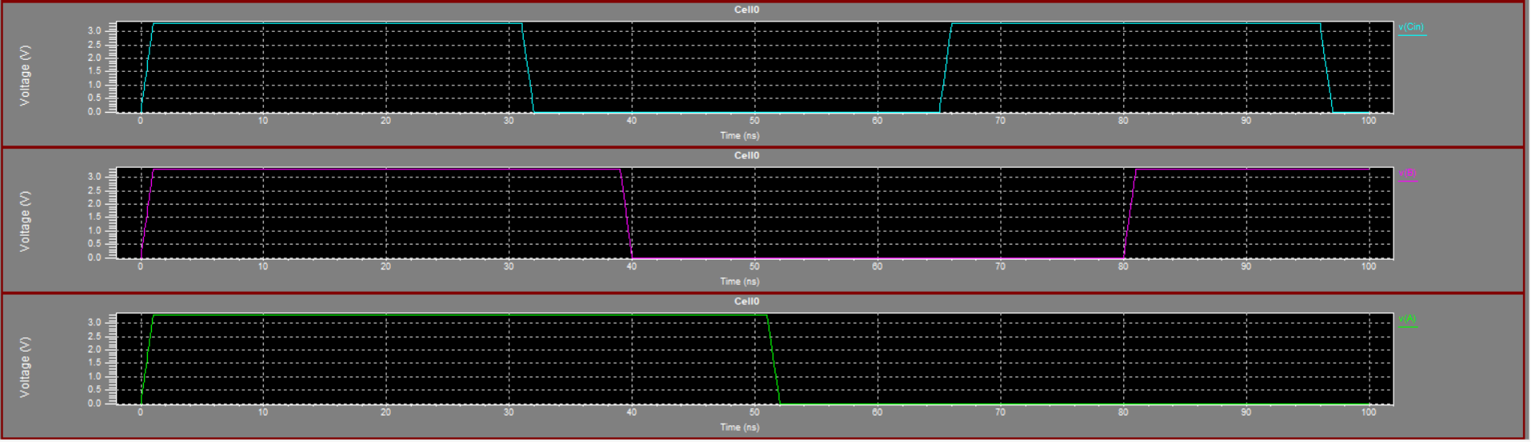

**OUTPUT WAVEFORM**

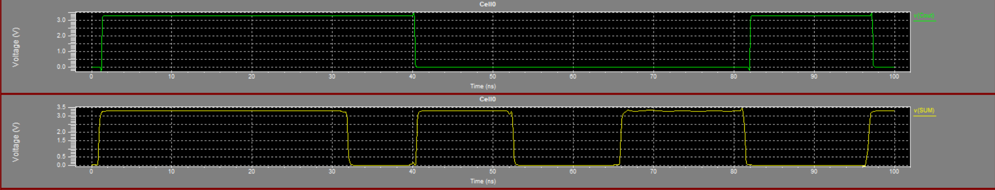

EDGE TRIGGERED **D** FLIP FLOP

**S-EDIT**

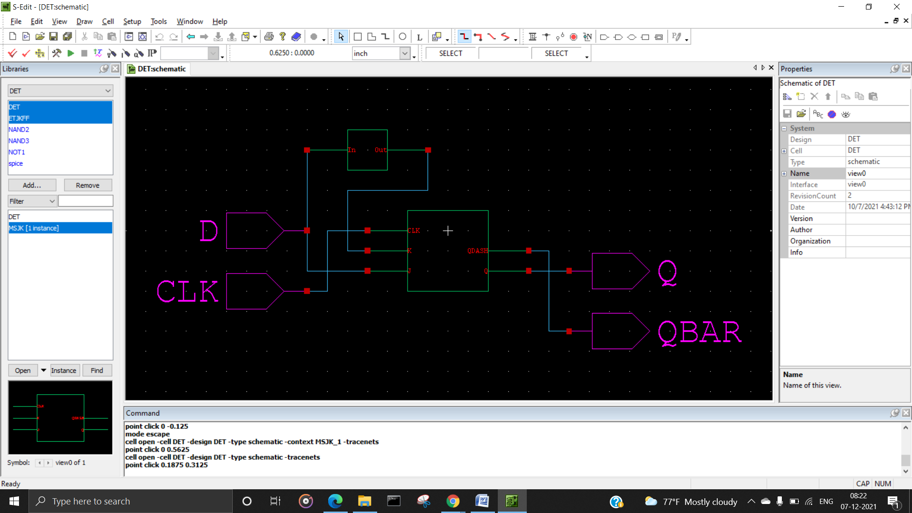

**INTERNAL MASTER SLAVE jk flipflop**

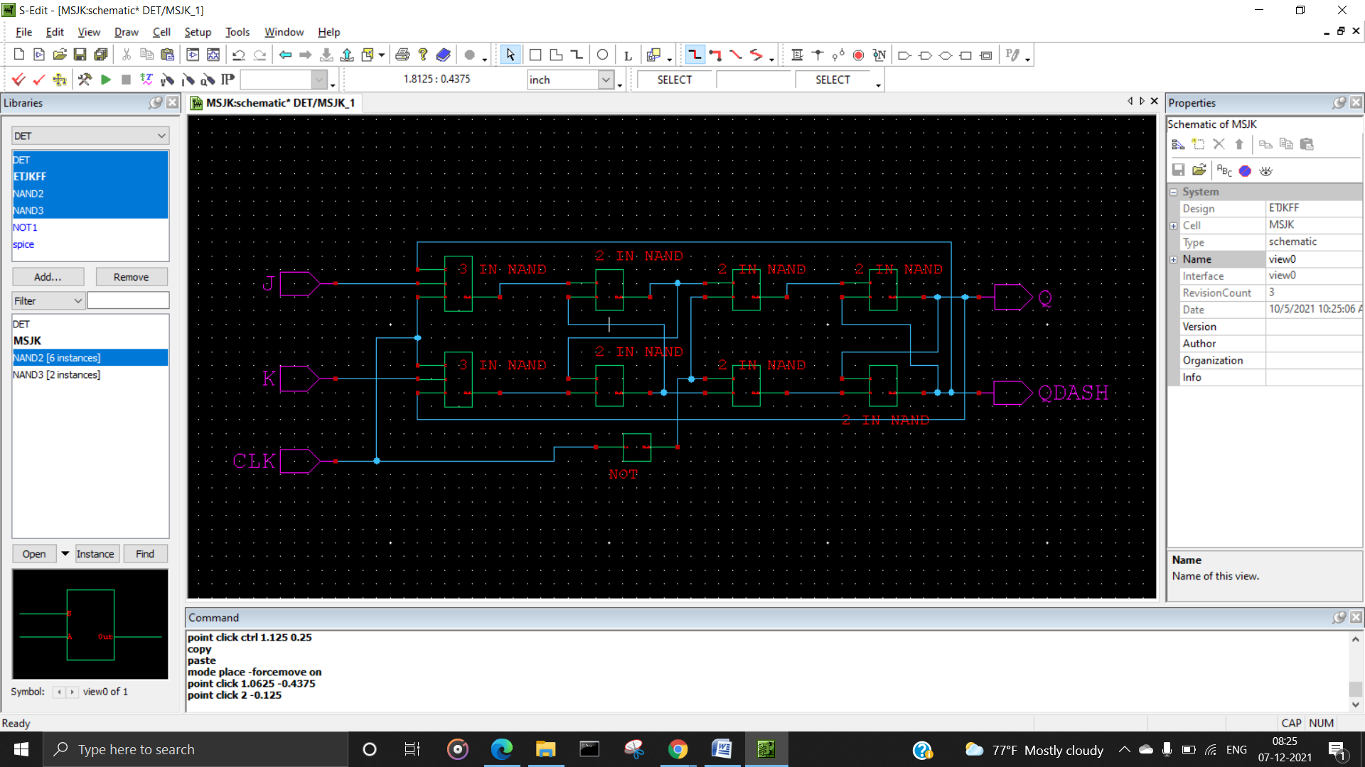

**T-SPICE**

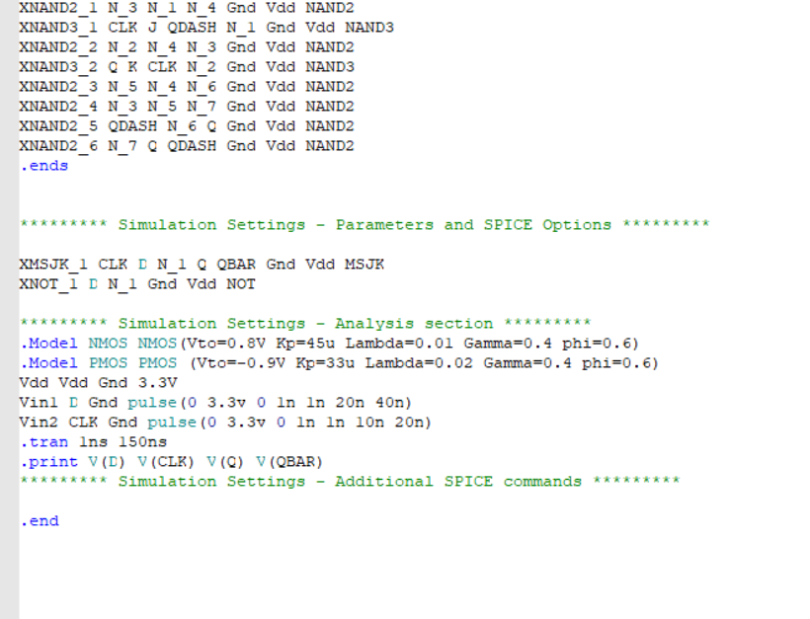

**W-EDIT WAVEFORM**

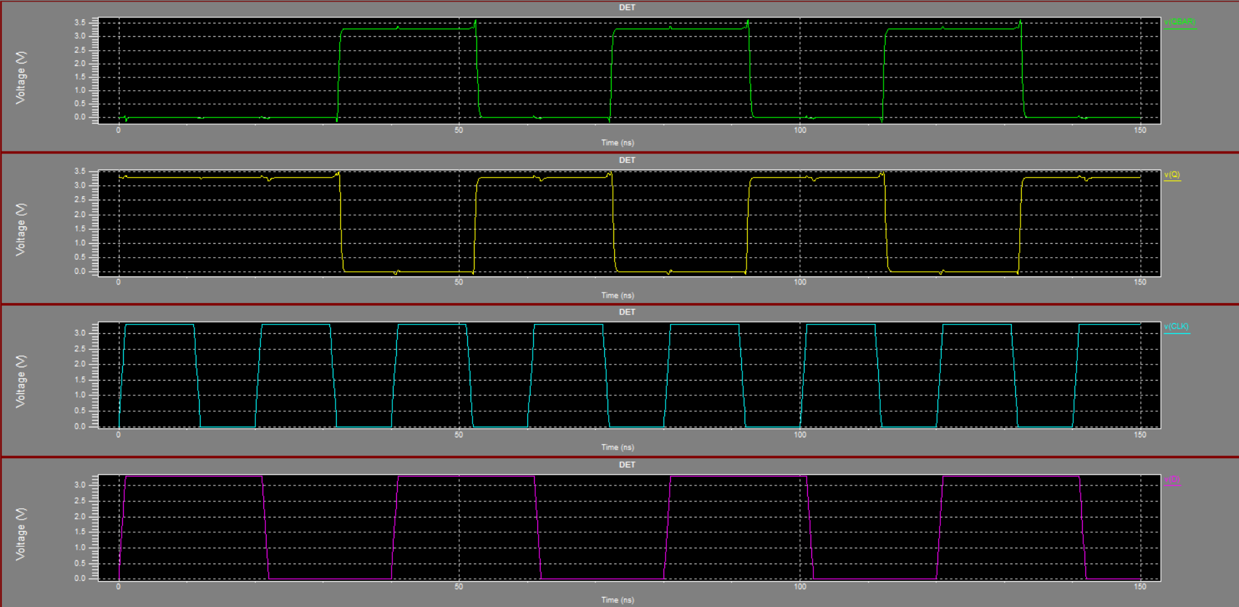

STANDARD **LFSR**

**S-EDIT**

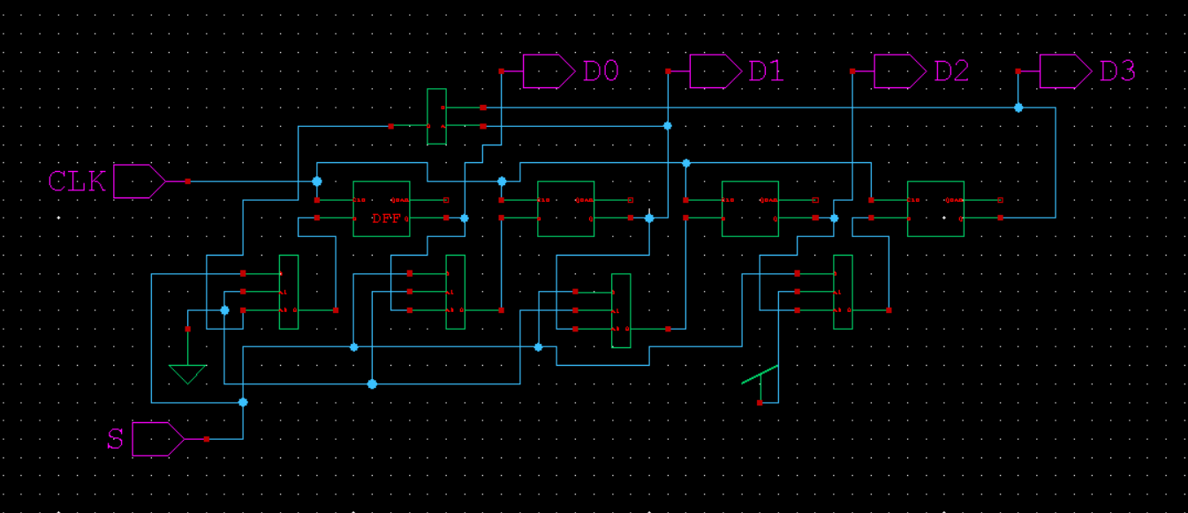

**T-SPICE**

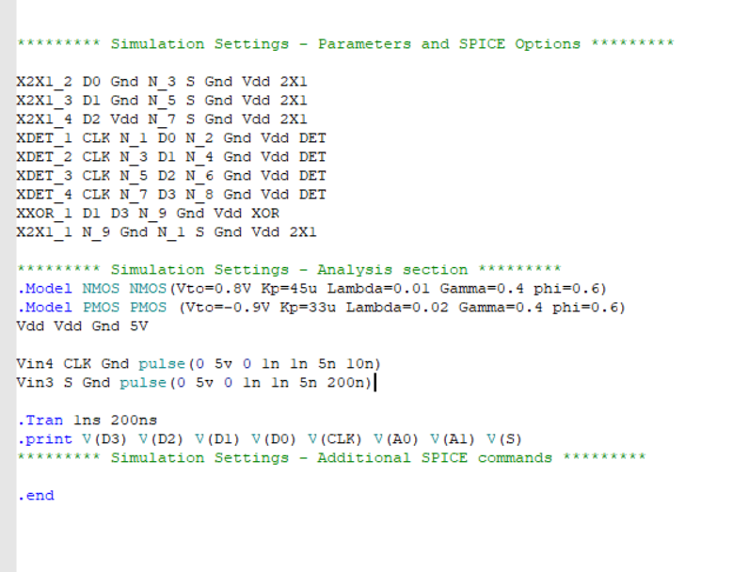

**W-EDIT WAVEFORM**

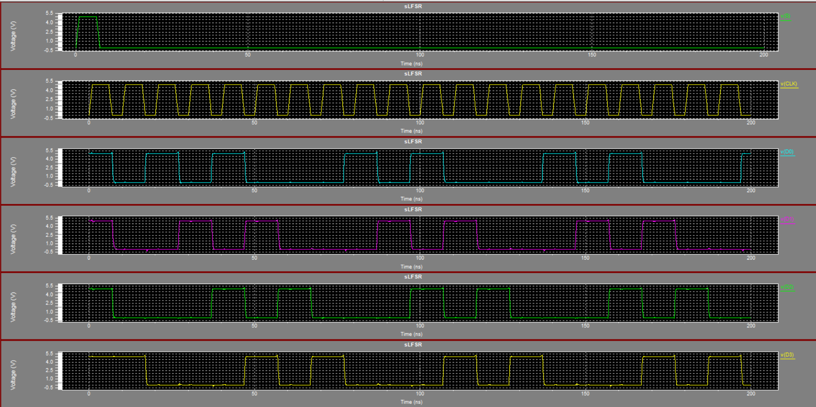

MODULAR **LFSR**

**S-EDIT**

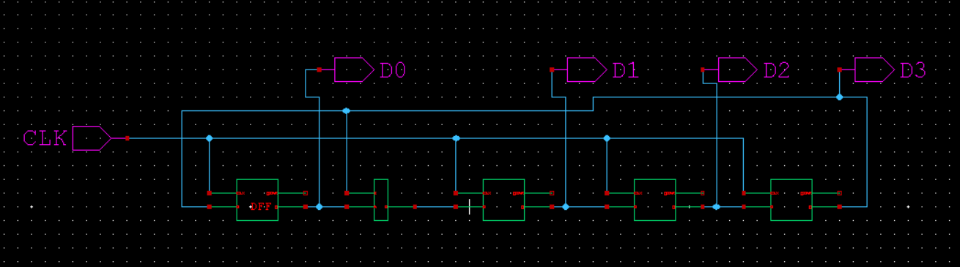

**T-SPICE**

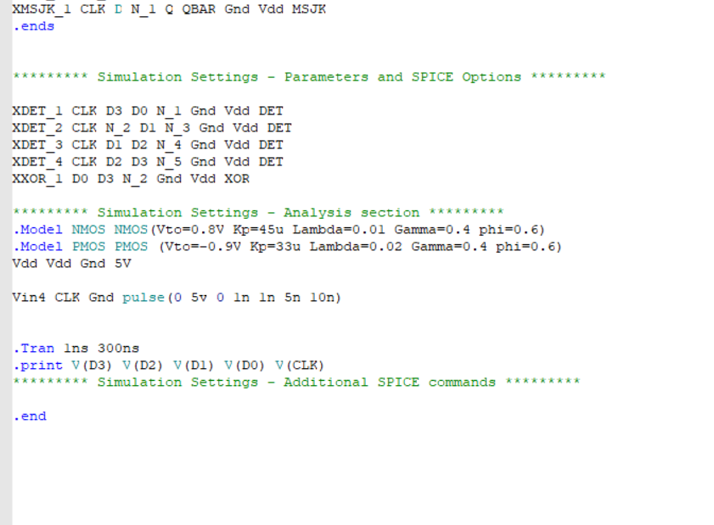

**W-EDIT WAVEFORM**

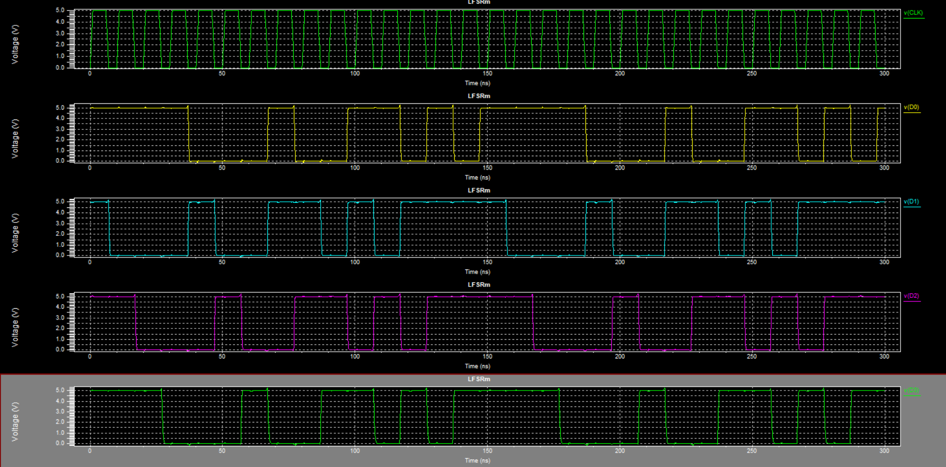

SRAM CELL

**S-EDIT**

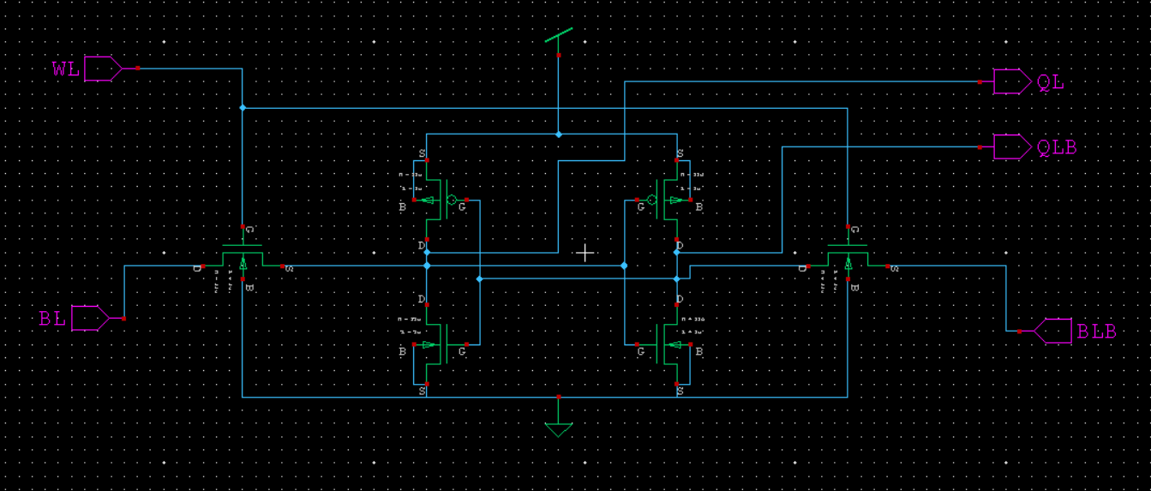

**T-SPICE**

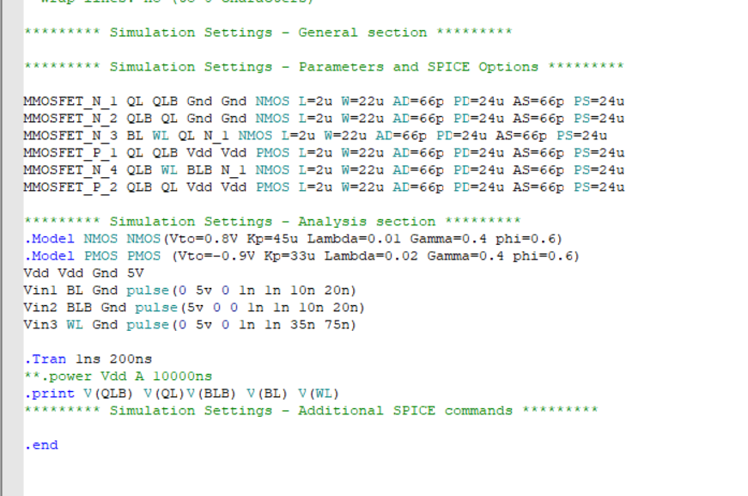

**W-EDIT WAVEFORM**

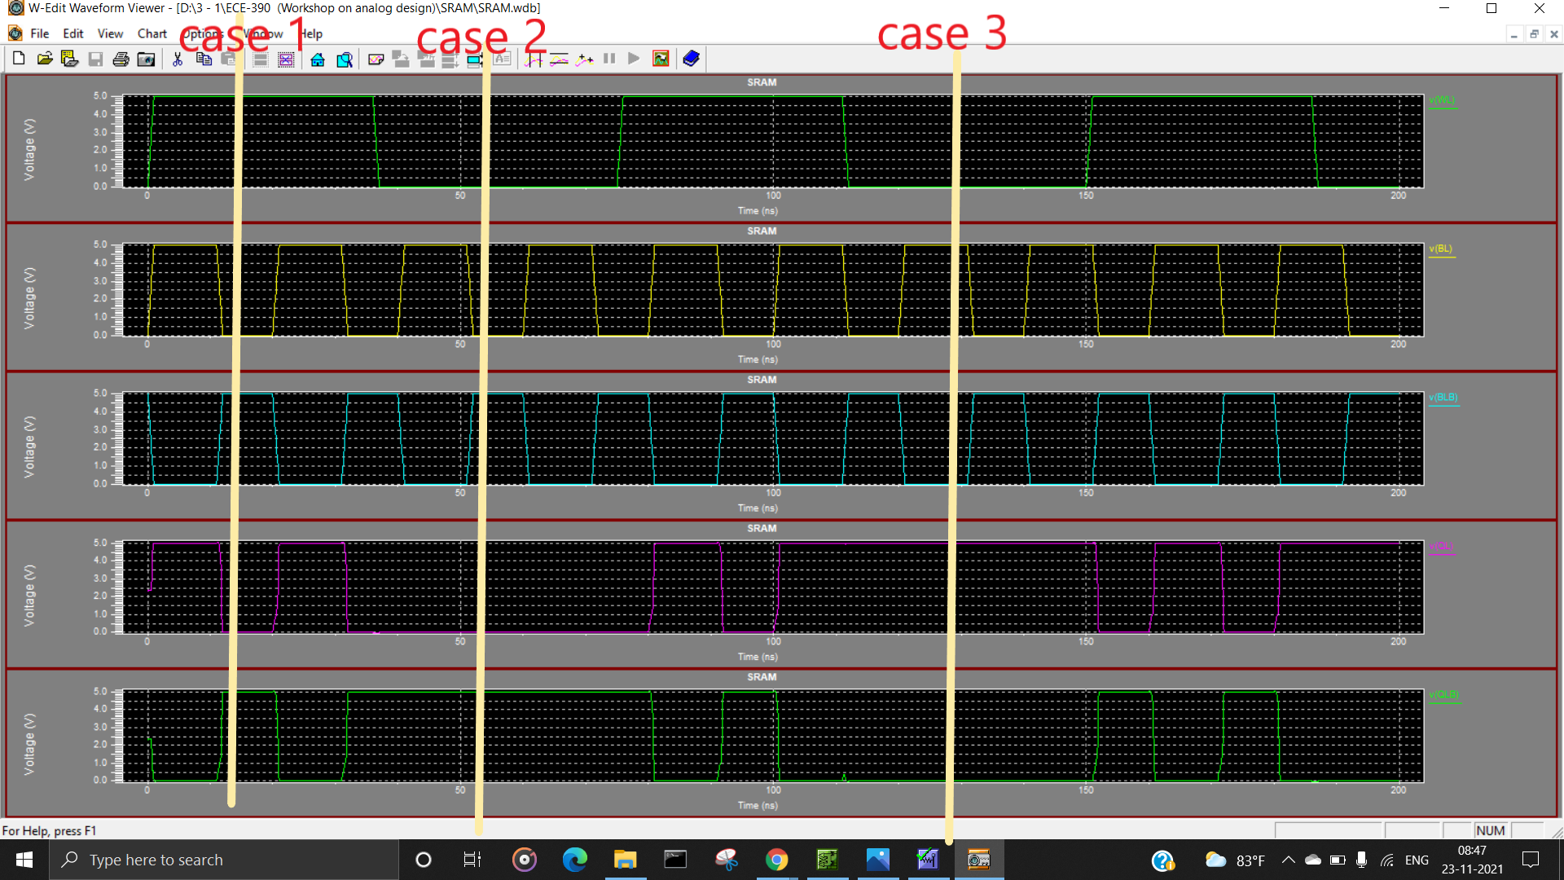

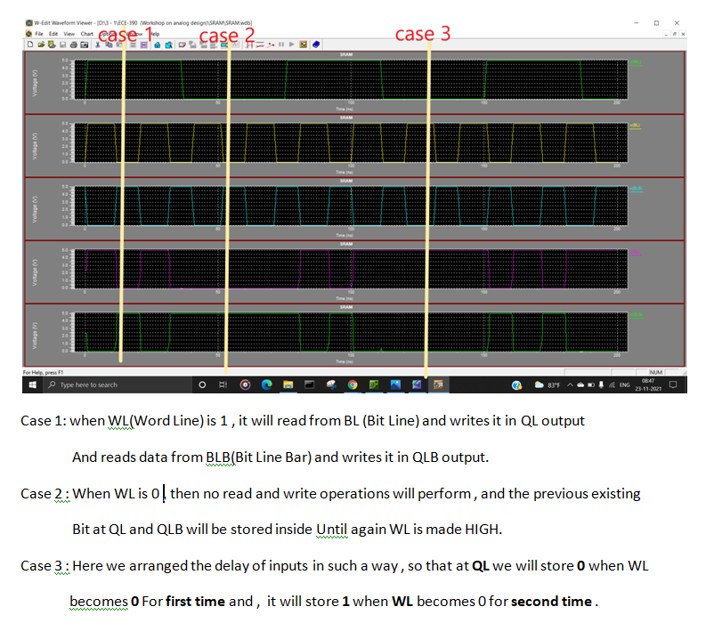

2 BIT ALU

**S-EDIT**

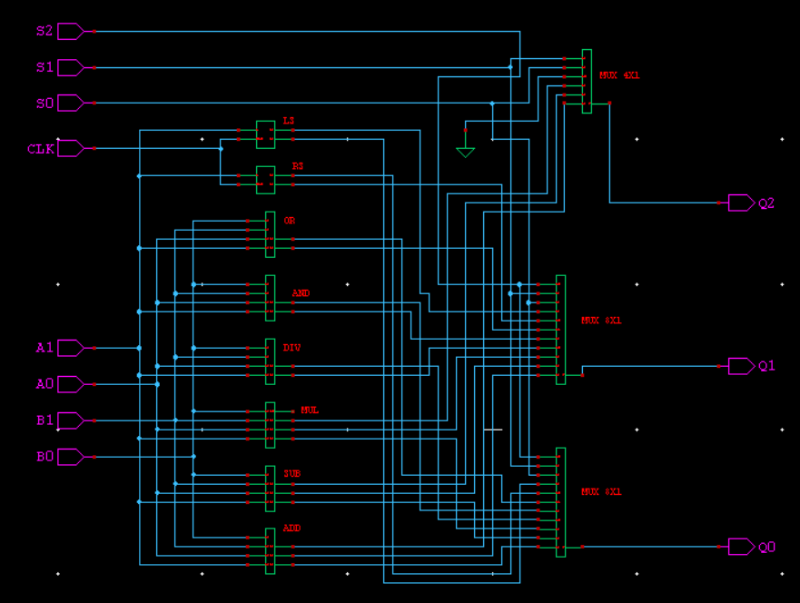

**INTERNAL CIRCUITS**

**ADDER**

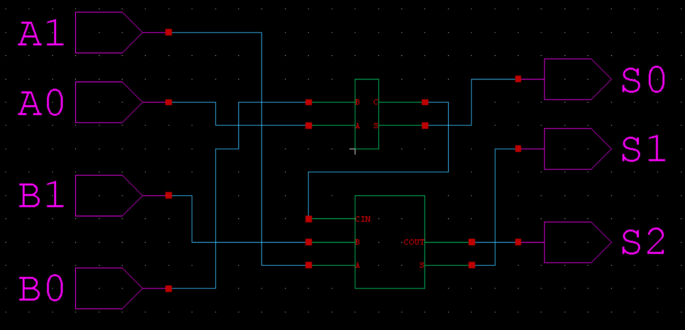

**SUBTRACTOR**

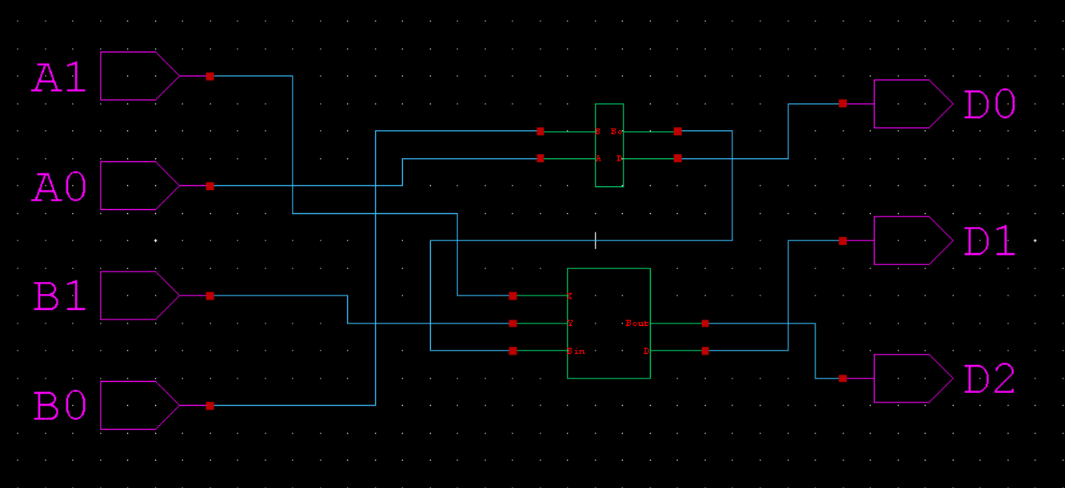

**MULTIPLIER**

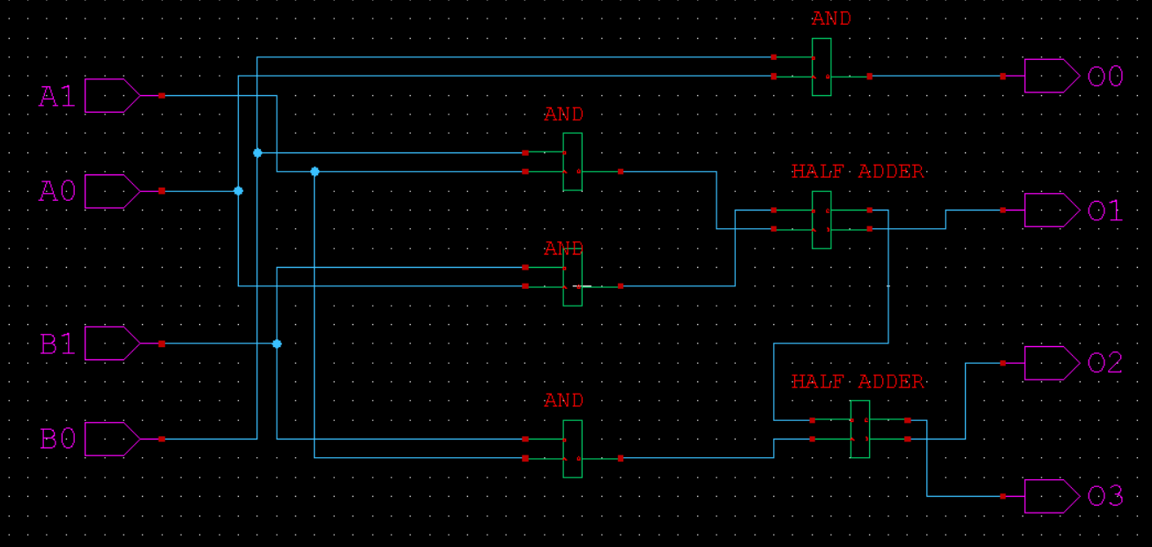

**DIVIDER**

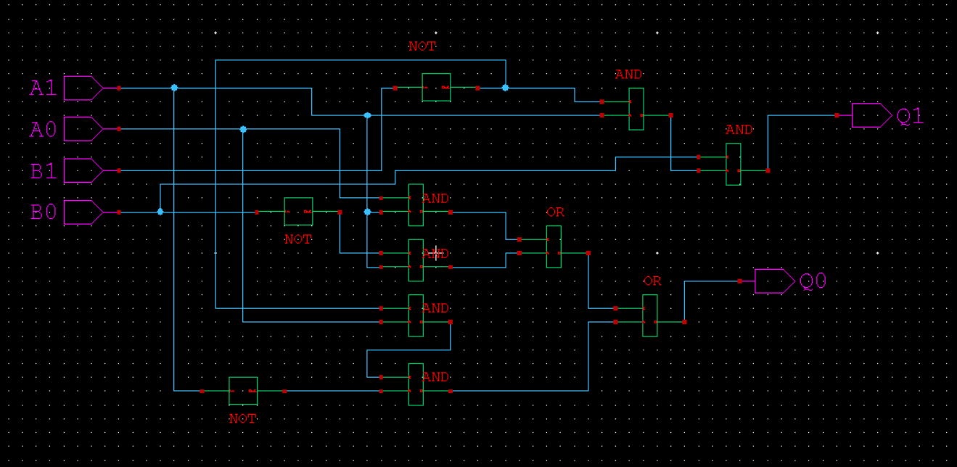

**2 BIT LOGICAL AND**

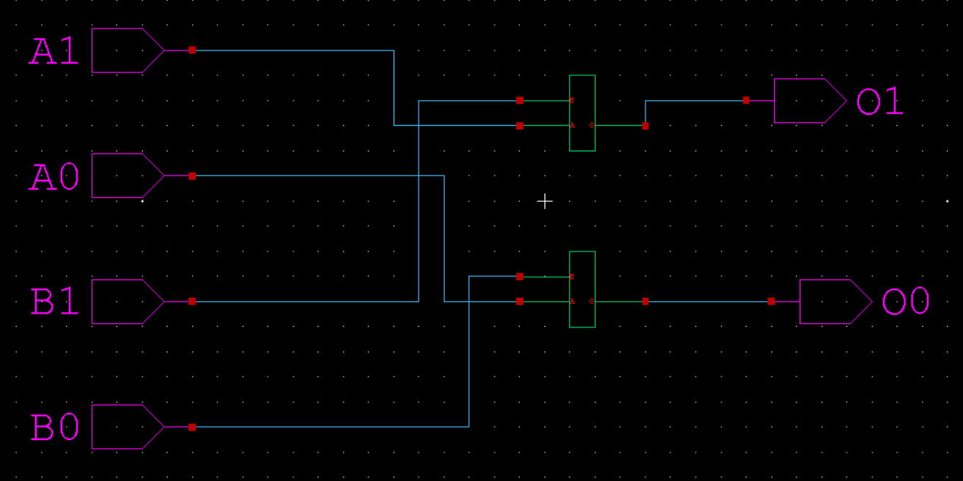

**2 BIT LOGICAL OR**

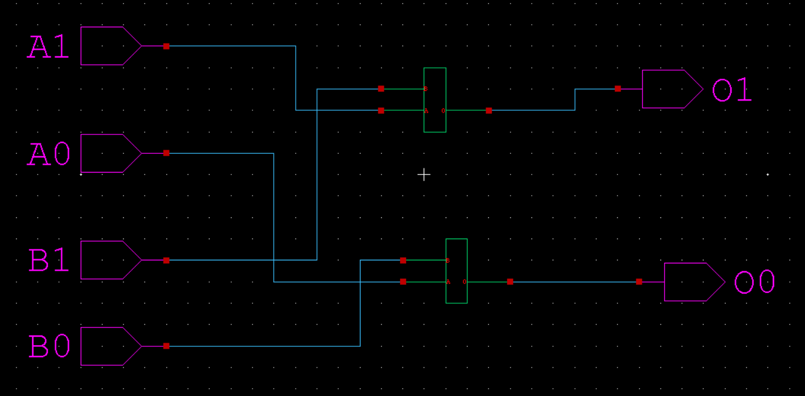

**RIGHT SHIFT**

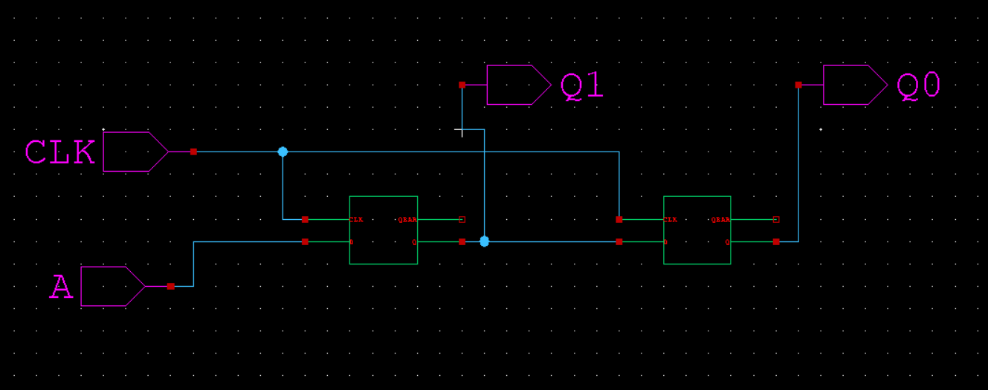

**LEFT SHIFT**

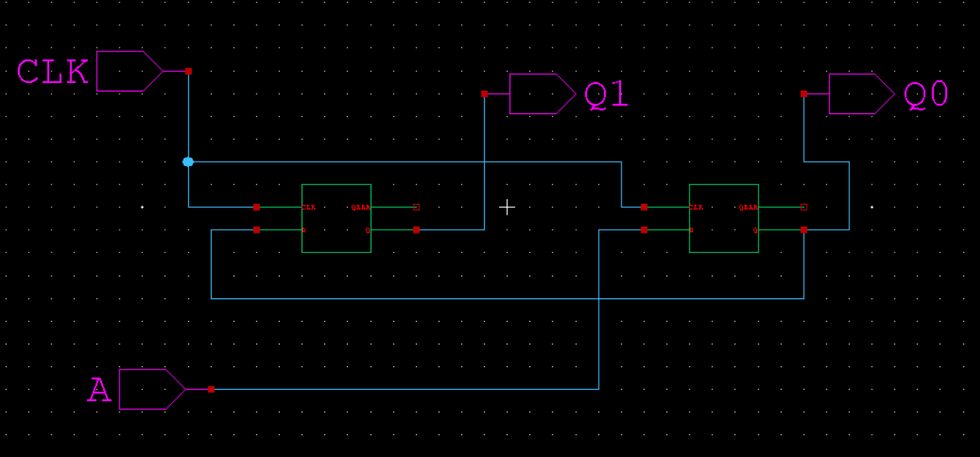

**8X1 MUX**

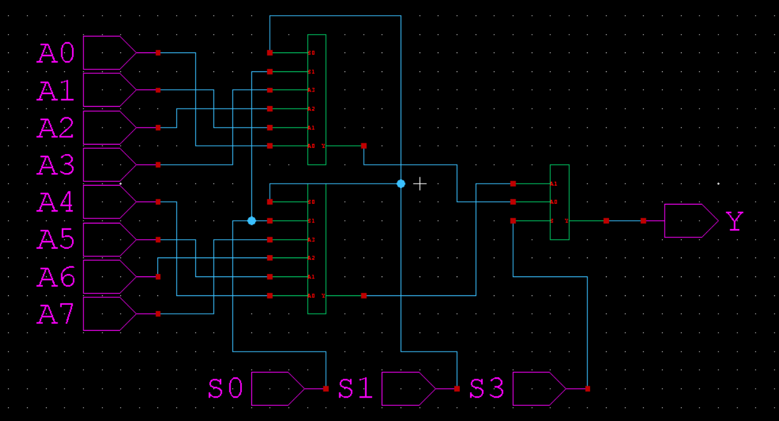

**4X1 MUX**

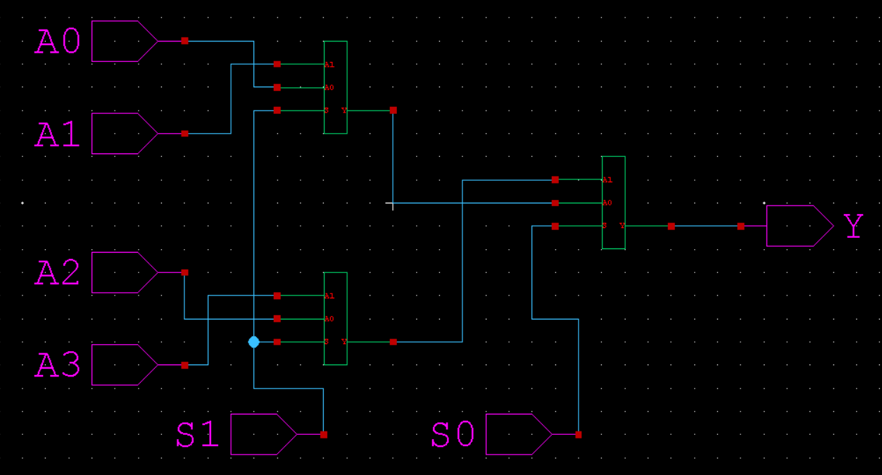

**2X1 MUX (TRANSITION MODEL)**

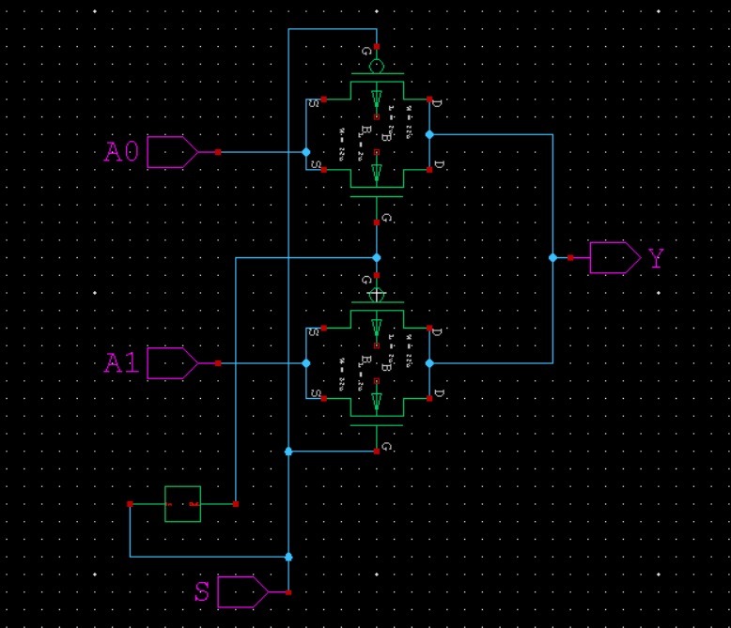

**T-SPICE**

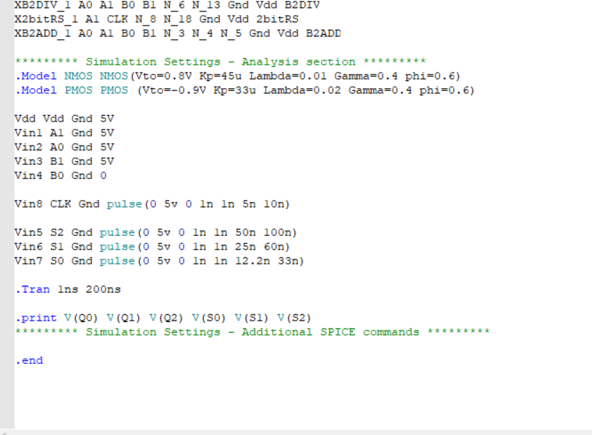

**W-EDIT WAVEFORM**

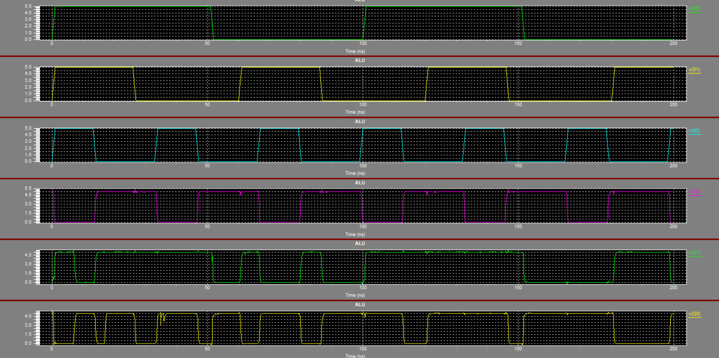

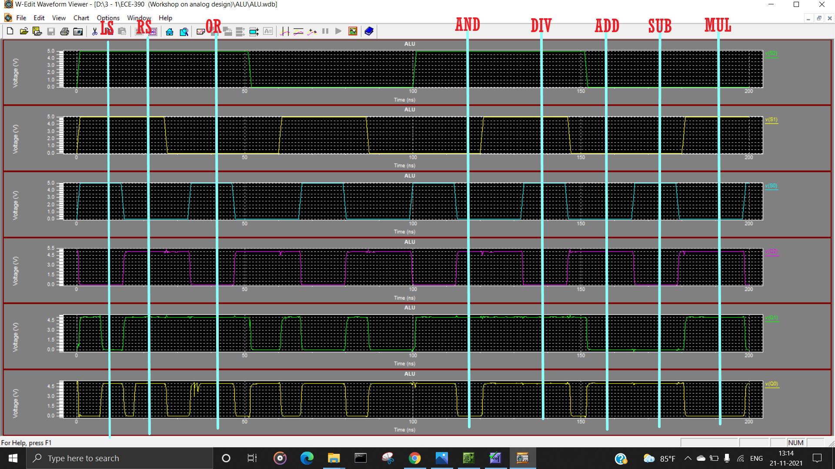

8 BIT MULTIPLEXER

**S-EDIT**



**T-SPICE**

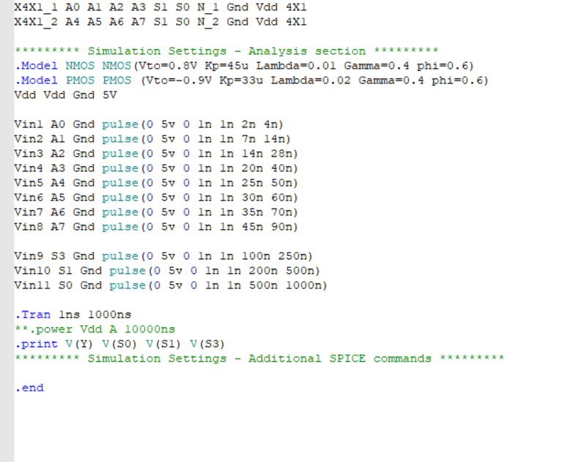

**W-EDIT WAVEFORM**

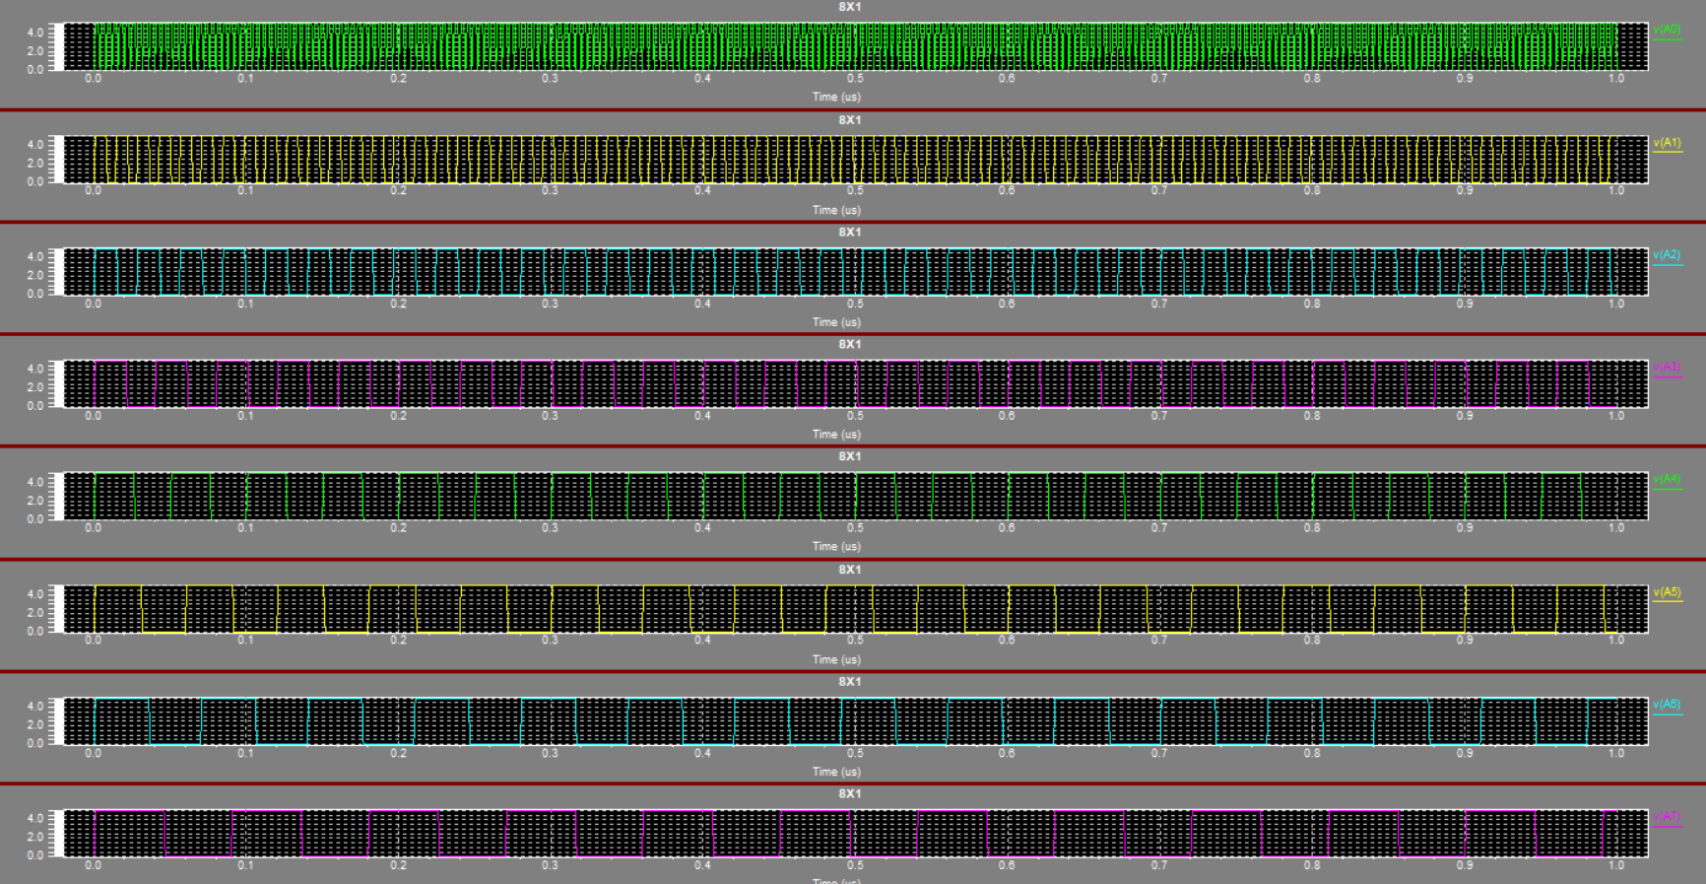

ROM

**S-EDIT**

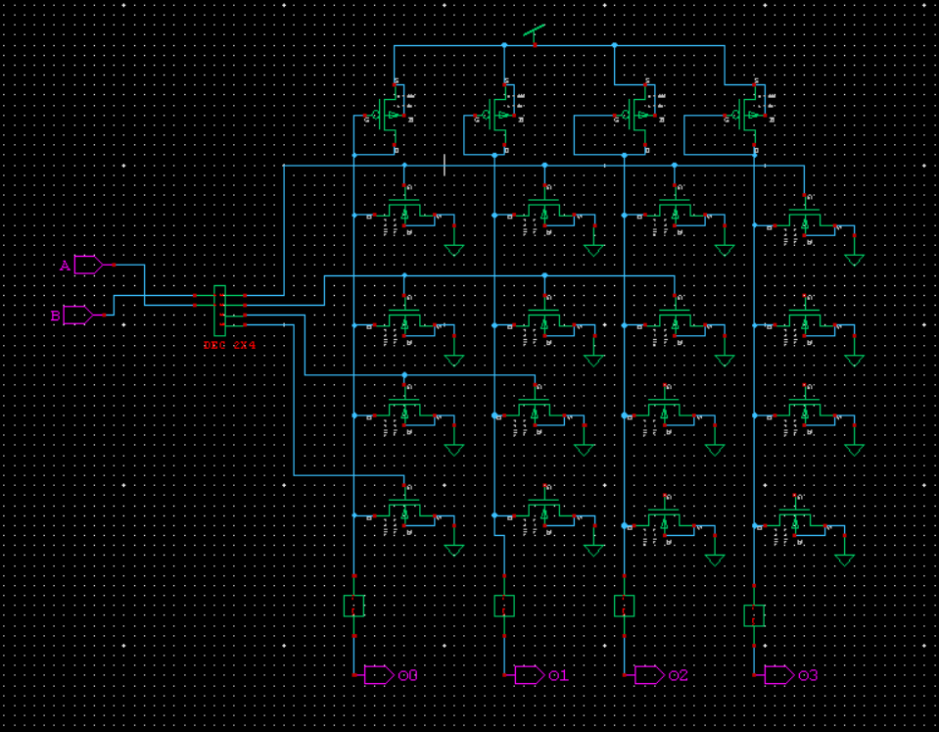

**T-SPICE**

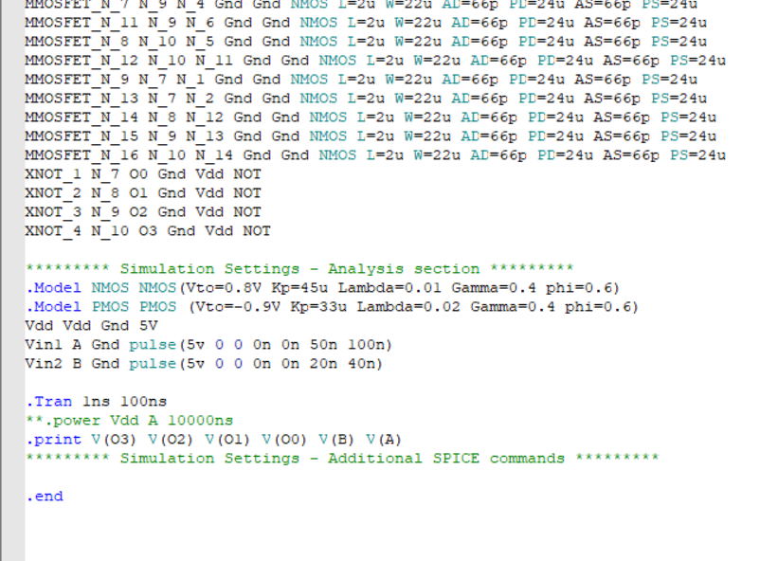

**W-EDIT WAVEFORM**

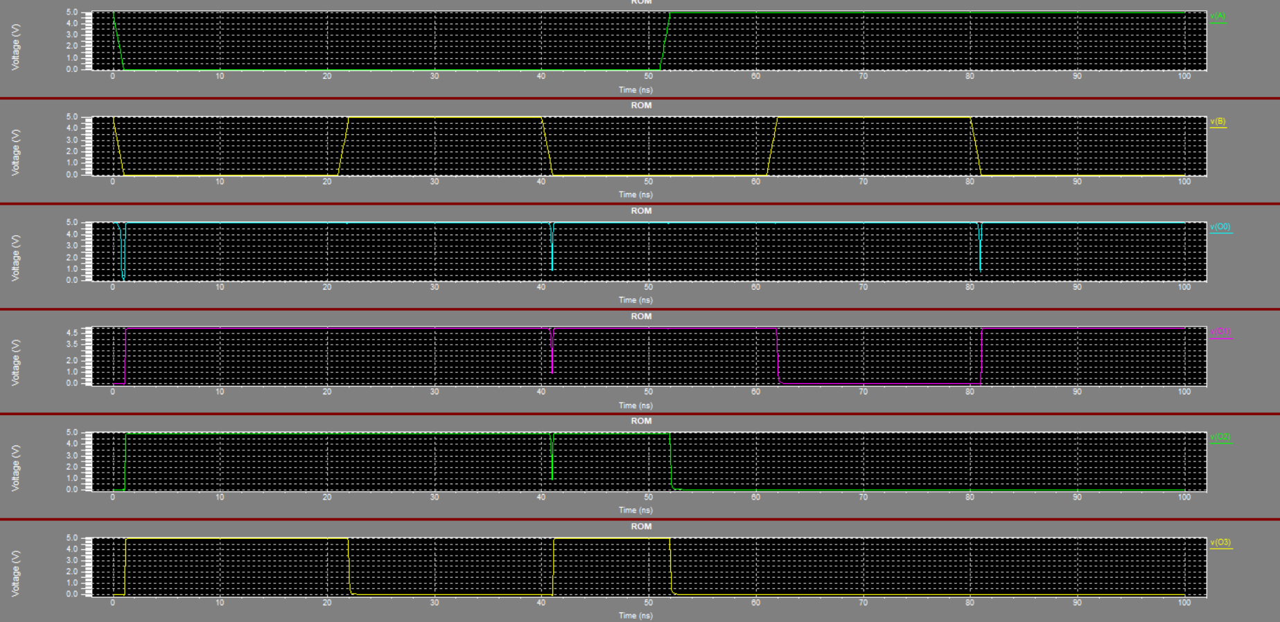

4X1 MUX

**S-EDIT**



**T-SPICE**

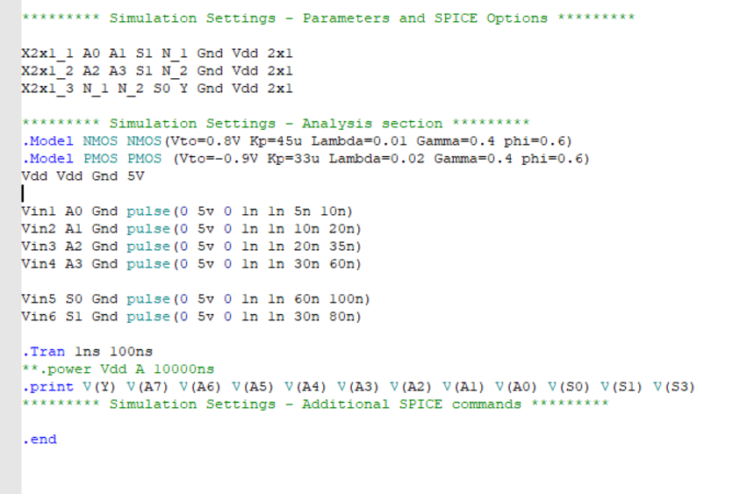

**W-EDIT WAVEFORM**

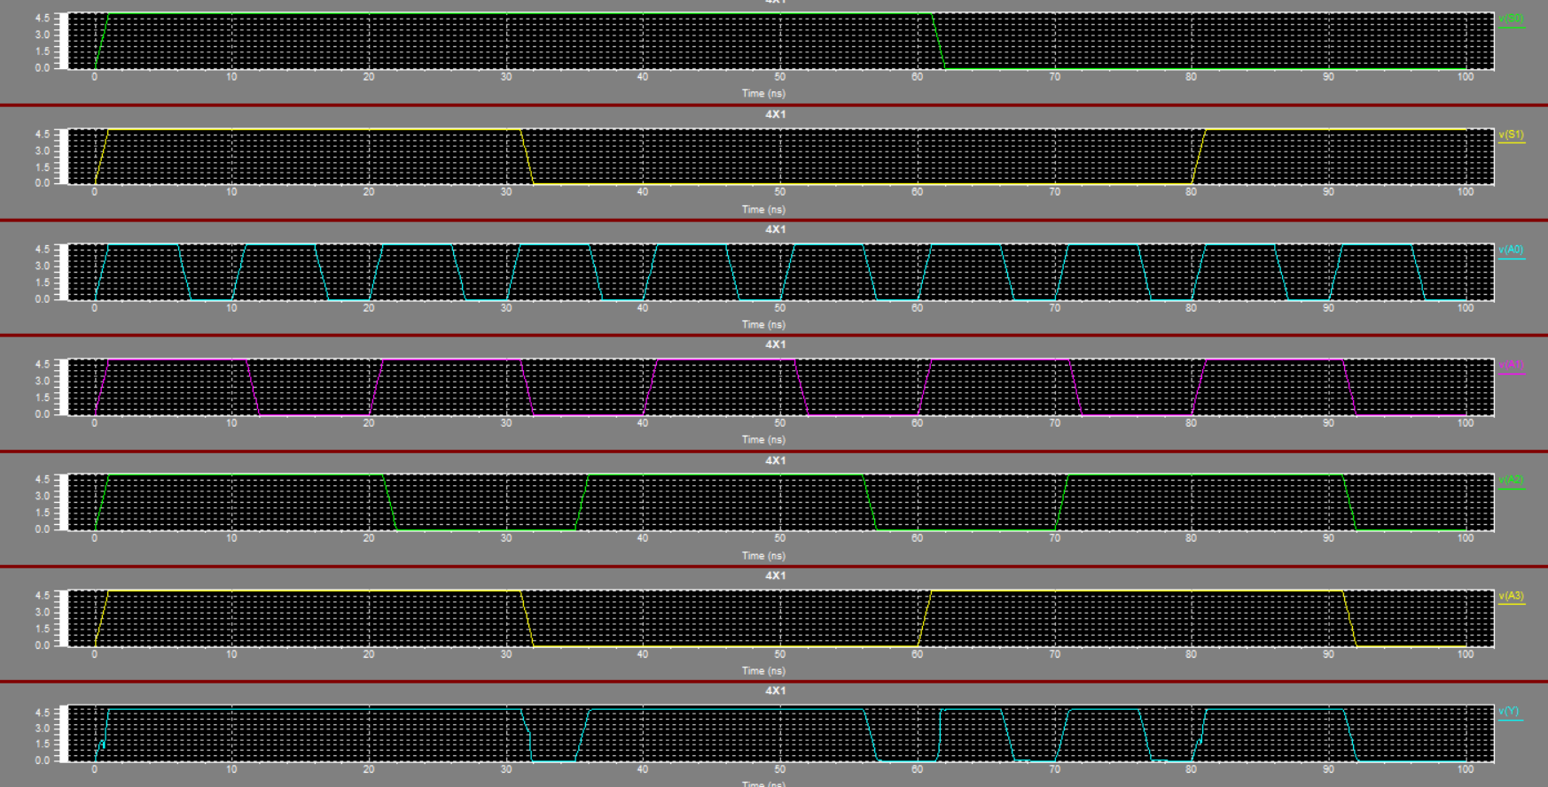

2X1 MUX

**S-EDIT**

**GATE MODEL**

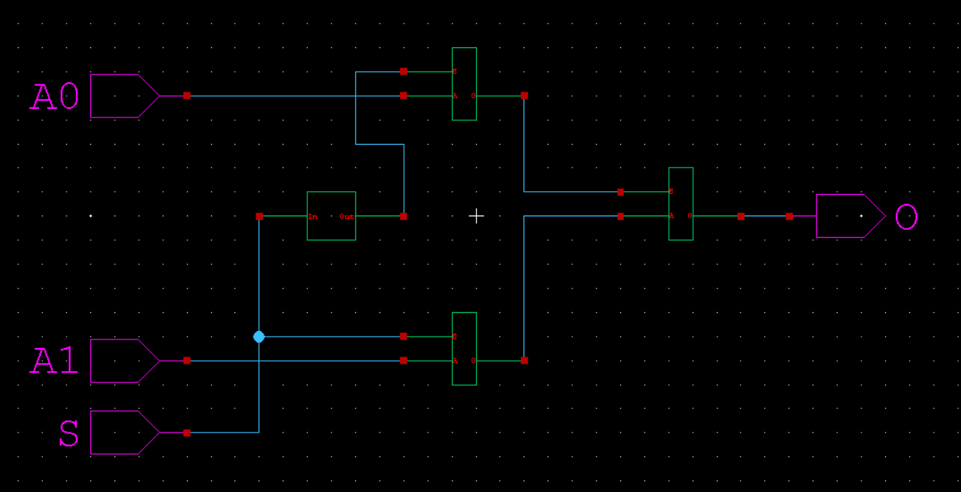

**TRANSITION MODEL**



**T-SPICE**

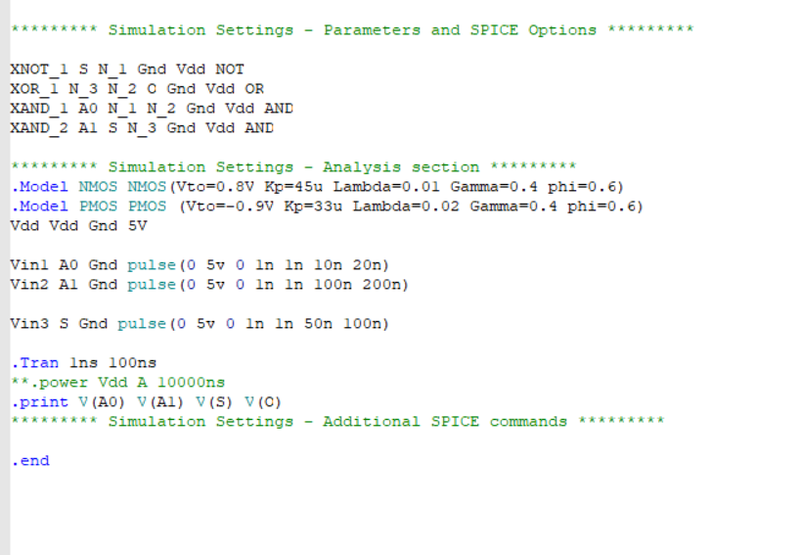

**W-EDIT WAVEFORM**

